UNITED STATES
SECURITIES AND EXCHANGE COMMISSION
Washington, DC 20549

SCHEDULE 14A INFORMATION
Proxy Statement Pursuant to Section 14(a) of the
Securities Exchange Act of 1934
(Amendment No. )

Filed by the Registrant ☒ Filed by a Party other than the Registrant ☐
Check the appropriate box:

☐ | Preliminary Proxy Statement

☐ | Confidential, for Use of the Commission Only (as permitted by Rule 14a-6(e)(2))

☐ | Definitive Proxy Statement

☒ | Definitive Additional Materials

☐ | Soliciting Material Pursuant to § 240.14a-12
Lumexa Imaging Holdings, Inc.
(Name of Registrant as Specified in Its Charter)
(Name of Person(s) Filing Proxy Statement, if other than the Registrant)
Payment of Filing Fee (Check the appropriate box):

☒ | No fee required.

☐ | Fee paid previously with preliminary materials.

☐ | Fee computed on table in exhibit required by Item 25(b) per Exchange Act Rules 14a-6(i)(1) and 0-11.


P.O. BOX 8016, CARY, NC 27512-9903 Your vote matters! Meeting Materials: Notice of Meeting and Proxy Statement & Annual Report or Form 10-K Important Notice Regarding the Availability of Proxy Materials for the Stockholder Lumexa Imaging Holdings, Inc. Meeting To Be Held On June 10, 2026 For Stockholders of record as of April 13, 2026 Annual Meeting of Stockholders To order paper materials, use one of the Wednesday, June 10, 2026 8:30 AM, Eastern Time Annual meeting to be held live via the internet—please visit www.proxydocs.com/LMRI for following methods. more details. You must register to attend the meeting online and/or participate at www.proxydocs.com/LMRI Internet: For a convenient way to view proxy materials, VOTE, and obtain www.investorelections.com/LMRI directions to attend the meeting go to www.proxydocs.com/LMRI To vote your proxy while visiting this site, you will need the 12 digit control number in the box below. Call: 1-866-648-8133 This communication presents only an overview of the more complete proxy materials that are available to you on the Internet. This is not a ballot. You cannot use this notice to vote your shares. We encourage you to access and review all of the important information contained in the proxy materials before voting. Email: paper@investorelections.com Under United States Securities and Exchange Commission rules, proxy materials do not have to be delivered in paper. Proxy materials can be distributed by making them available on the * If requesting material by e-mail, please send a blank e-mail with the internet. 12 digit control number (located below) in the subject line. No other requests, instructions OR other inquiries should be included with your If you want to receive a paper or e-mail copy of the proxy material, you must request one. e-mail requesting material. There is no charge to you for requesting a copy. In order to receive a paper package in time for this year’s meeting, you must make this request on or before May 29, 2026. Your control number Have the 12 digit control number located in the box above available when you access the website and follow the instructions. Copyright © 2026 BetaNXT, Inc. or its affiliates. All Rights Reserved

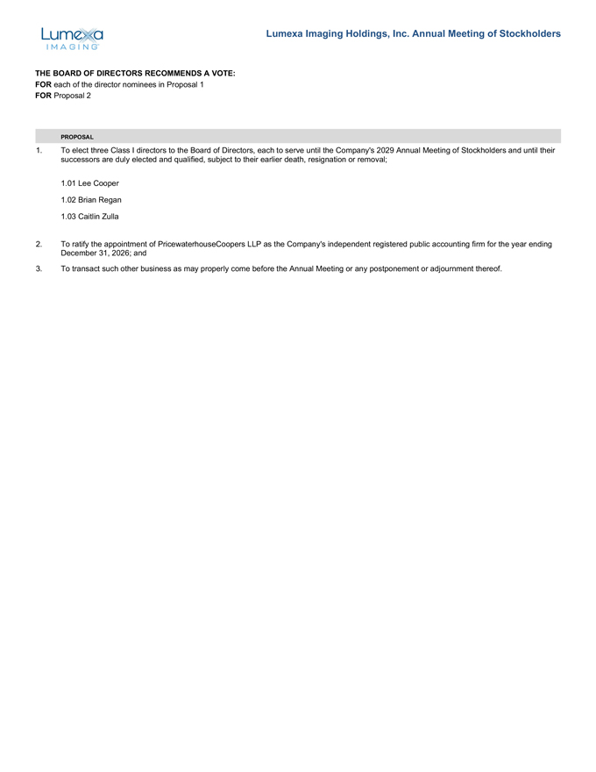
Lumexa Imaging Holdings, Inc. Annual Meeting of Stockholders THE BOARD OF DIRECTORS RECOMMENDS A VOTE: FOR each of the director nominees in Proposal 1 FOR Proposal 2 PROPOSAL 1. To elect three Class I directors to the Board of Directors, each to serve until the Company’s 2029 Annual Meeting of Stockholders and until their successors are duly elected and qualified, subject to their earlier death, resignation or removal; 1.01 Lee Cooper 1.02 Brian Regan 1.03 Caitlin Zulla 2. To ratify the appointment of PricewaterhouseCoopers LLP as the Company’s independent registered public accounting firm for the year ending December 31, 2026; and 3. To transact such other business as may properly come before the Annual Meeting or any postponement or adjournment thereof.

